Dear Sophia

Have a nice day.

I'm Mark for Shanghai Ifly GSE company, nice to contact with you. we are glad to receive your RFQ ,thanks your trust for us,
Shanghai Ifly GSE is a professional manufacturer for maintenance,tooling, dock , tow bar ,engine stand, washers and jacks ..... in China.
we have capability to provide line maintenance tooling series: B737, A320, A330, A350....for these most popular aircraft on the market.
there has airlines ,MRO and distrbutors , they are satisfied with our excellent quality.
i'm sure you will be happy too after you get our tooling.

Here i want to introduce more about our company, we have a video to let our customers know we are making
products very seriously ,we have a big and clear workshop ,excellent engineer team and hard working workers,we
will provide excellent products to customers all over the world .
here is our video link : About Ifly - Shanghai Ifly GSE Co.,Ltd.

Pls check our quickly offer on below, if you have any questions or new RFQ, pls let me know.

Shanghai Ifly GSE Co.,Ltd
Web:www.iflygse.com
E-mail: mark@iflygse.com
WhatsApp / Skype：+86-15216798723
NO. | Part Number | Description | Price(USD) | Lead time (Days) | Quantity | Condition | Unit | Sum(USD)
1 | CHS943 | SPANNER | 145 | 25 | 1 | NEW | EA | $145.00
合计 Amount(USD) |  |  |  |  | 1 |  |  | $145.00
Payment Term： |  |  | Terms of Delivery:
40% as Per-payment,balance before shipping out |  |  | EXW-Factory (Shanghai,China)
Remark： |  | Validity of quote:90 days
 |  | Condition/Certification: New /MFG C/C
 |  | Warranty period: One Year

This is our factory photos:
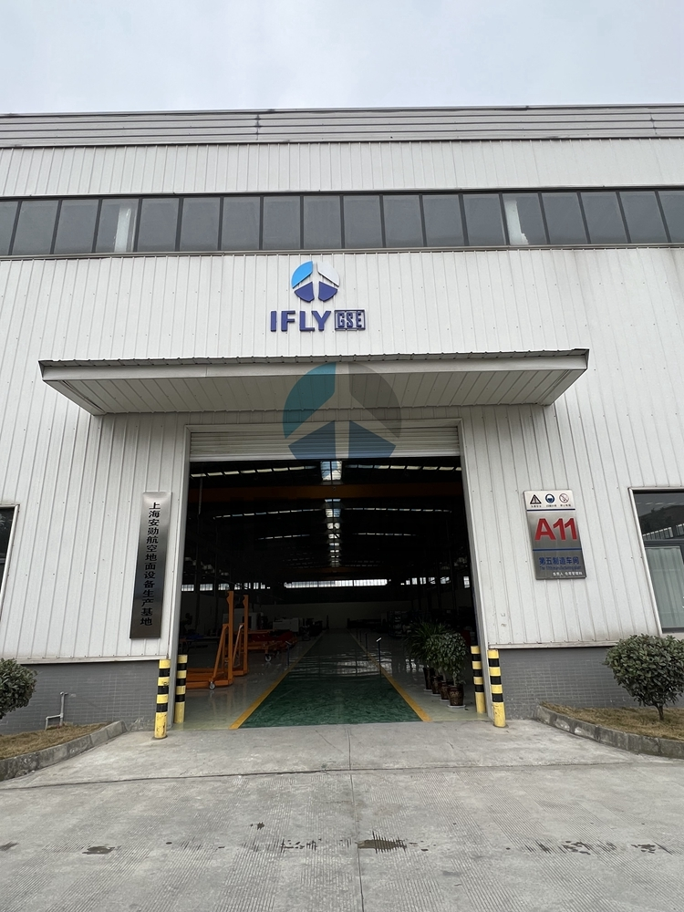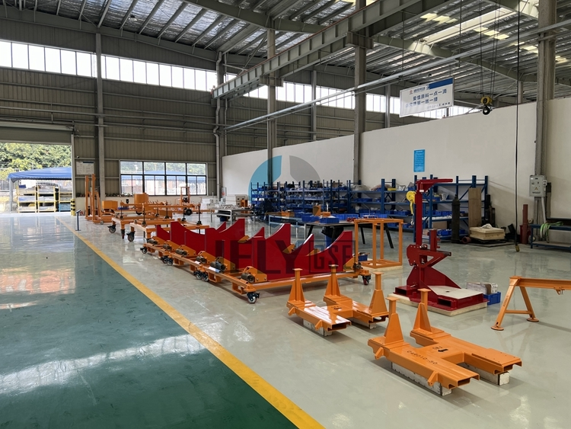

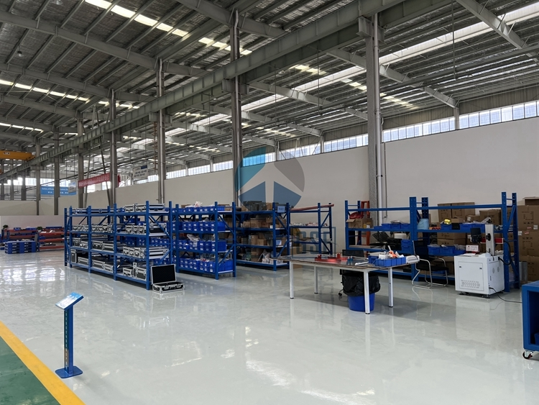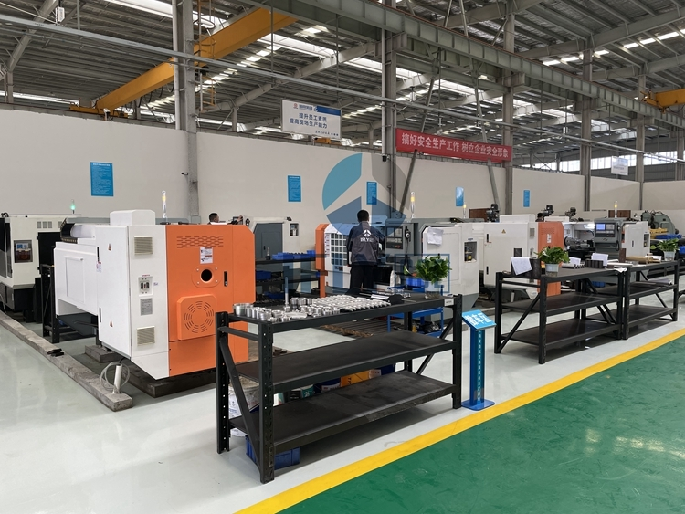

To know more about Ifly GSE team , here is our video link:
About Ifly - Shanghai Ifly GSE Co.,Ltd.

Regards
Mark

Sales Director
Shanghai Ifly GSE Co.,Ltd.
Tel: +86-021-20980670
Fax: +86-021-20980670
E-mail: mark@iflygse.com
Web:www.iflygse.com
Contact: Mark
Mobile Phone:+86-15216798723(24hours)
WhatsApp / Skype：+86-15216798723
Add: Room 1508,Building 4,No 500 JianYun Road,Pudong,Shanghai,China.
Professional manufacturer for maintenance dock, engine stand,tow bar, Jacks.....
Please consider the environment before printing this e-mail

From: Sophia Yan
Date: 2023-05-24 21:06
To: 'mark@iflygse.com'
Subject: RFQ-3398E
Dear Mark,

Thank you in advance for your consideration.
I would appreciate to quote us your best for the following items including delivery time.
Please bear in mind to send us all related documents.

No. | Part Number | Description | QTY
1 | CHS943 | SPANNER | 1

Regards
Sophia Yan
 |  | Room 218-9, 2/Floor, Block B,Proficient Industrial Centre,6 Wang Kwun Road, Kowloon Bay, Hong Kong.
 |  | Phone: +85281700369
 |  | www.HenixioAviation.com
 |  | s.yan@HenixioAviation.com

